**STAT 500 Homework 2**

1. Out put of the regression model with wages as the response and years of education and experience as preditors:

Code:

>library (faraway)

##read in and check out the data

>data (uswages)

>attach (uswages)

>uswages

uswages$exper[uswages$exper < 0] <- NA

>dim ( uswages )

>n = dim ( uswages ) [1]

>p = dim ( uswages ) [2]

>x = cbind ( 1, as.matrix(uswages [,] ))

>reg = lm( wage ~ educ + exper, data = uswages)

>summary(reg)

Call:

lm(formula = wage ~ educ + exper, data = uswages)

Residuals:

Min 1Q Median 3Q Max

-1014.7 -235.2 -52.1 150.1 7249.2

Coefficients:

Estimate Std. Error t value Pr(>|t|)

(Intercept) -239.1146 50.7111 -4.715 2.58e-06 ***

educ 51.8654 3.3423 15.518 < 2e-16 ***

exper 9.3287 0.7602 12.271 < 2e-16 ***

---

Signif. codes: 0 ‘***’ 0.001 ‘**’ 0.01 ‘*’ 0.05 ‘.’ 0.1 ‘ ’ 1

Residual standard error: 426.8 on 1964 degrees of freedom

(33 observations deleted due to missingness)

Multiple R-squared: 0.1348, Adjusted R-squared: 0.1339

F-statistic: 153 on 2 and 1964 DF, p-value: < 2.2e-16

2. What percentage of variation in the response is explained by these predictors?

Code:

>regs <- summary(reg)

>names (regs)

## extract R2

>regs $ r.squared

0.134793

Answer: Since the Multiple R-squared is 0.134793, it shows that nearly 13.48 % of the variation in the response is explained by these predictors.

3. Which observation has the largest (positive) residual? Give the case number.

Code:

>rsd= as.vector(regs$residuals)

>which.max (rsd)

[1] 1550

Answer: The No. 1550 case has the largest positive residual.

4. Compute the mean and median of the residuals. Explain what the difference between the mean and the median indicates.

Code:

>mean(rsd)

[1] -1.381535e-15

> median(rsd)

[1] -52.14337

Answer: The mean of the residuals is -1.381535e-15, and the median is -52.14337. The median indicates that half of the residuals was less than -52.14337, while the mean indicates that the average residual is -1.381535e-15 ≈0,it may be effected by the extremely large or small data.

5. Compute the correlation of the residuals with the fitted values. Plot residuals against fitted values.

Code:

> cor ( rsd, reg$fitted.values)

[1] 6.35678e-17

> plot (rsd, reg$fitted.values,log = 'y',main="correlation of the residuals with the fitted values",ylim=c(80,1500), xlim=c(-1050,2250),ylab="Fitted

Values",xlab="Residuals")

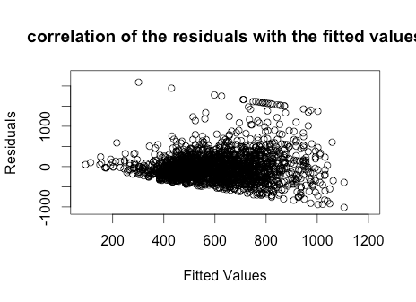

6. For two people with the same education and one year difference in experience, what would be the difference in predicted weekly wages?

Answer: See output in summary, the estimate coefficient of experience is 9.3287, that is the difference in predicted weekly wages.

7. Fit the same model but with log (weekly wages) as the response and interpret the regression coefficient for experience. Which model has a more natural interpretation?

Code:

>log_wage <-log (uswages$wage)

>log_reg <- lm ( log_wage ~ educ + exper, data = uswages)

>summary(log_reg)

Call:

lm(formula = log_wage ~ educ + exper, data = uswages)

Residuals:

Min 1Q Median 3Q Max

-2.7527 -0.3383 0.1002 0.4297 3.5728

Coefficients:

Estimate Std. Error t value Pr(>|t|)

(Intercept) 4.675518 0.077085 60.65 <2e-16 ***

educ 0.091940 0.005080 18.10 <2e-16 ***

exper 0.016516 0.001156 14.29 <2e-16 ***

---

Signif. codes: 0 ‘***’ 0.001 ‘**’ 0.01 ‘*’ 0.05 ‘.’ 0.1 ‘ ’ 1

Residual standard error: 0.6488 on 1964 degrees of freedom

(33 observations deleted due to missingness)

Multiple R-squared: 0.1747, Adjusted R-squared: 0.1739

F-statistic: 207.9 on 2 and 1964 DF, p-value: < 2.2e-16

Answer:

The regression coefficient for experience 0.016516 is smaller than before, which will make it easy to calculate estimate response.

And since the R-squared 0.1747 in this case is more closer to 1 than the former R-squared 0.1348, the fit with log (weekly wages) as the response is better and has a more natural interpretation.